**What is Fair Design?**

**Introduction**

Fair Design is a design principle that aims to ensure each social groups have the access necessary to receive the intended service of a product or innovation. The framework gauges social privileges of the users, and measures access by their proximity to intended information. Design guides our access to information. Yet due to unfair design practices, products and services may unintentionally build barriers and discriminate social groups. The goal of fair design is to proactively prepare for a future that is inclusive, and leaves no one behind.

**History of Fair Design**

Fair1

*[fair] adjective*

1Free from bias, dishonesty, or injustice.

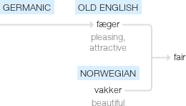

Fair Design is inspired by the frameworks of Accessibility Design (Designing for Disability), Inclusive Design (Designing for Diversity) and Universal Design (Designing for All). Fair Design also adopts mandates from design activisms groups across the globe, to understand specific needs of social groups. The output of the fair design framework is a product or service that spark pleasing yet accessible experiences to target social groups.

Fair Design was conceptualized in 2018, when I was researching user experience design as a discipline and pedagogy. With assistance from Dr. Olivier St.Cyr of University of Toronto, I created a reading course titled “Fair Design – Ethical Frameworks for Inclusive Design Principles”, where I published an essay and design methodology that can be used by others to begin incorporating fair design practices into their product or service design.

The research continues today, and as a collaborative design framework, the Fair Design community seeks any contributors or input from every single person, who has a human experience to share.

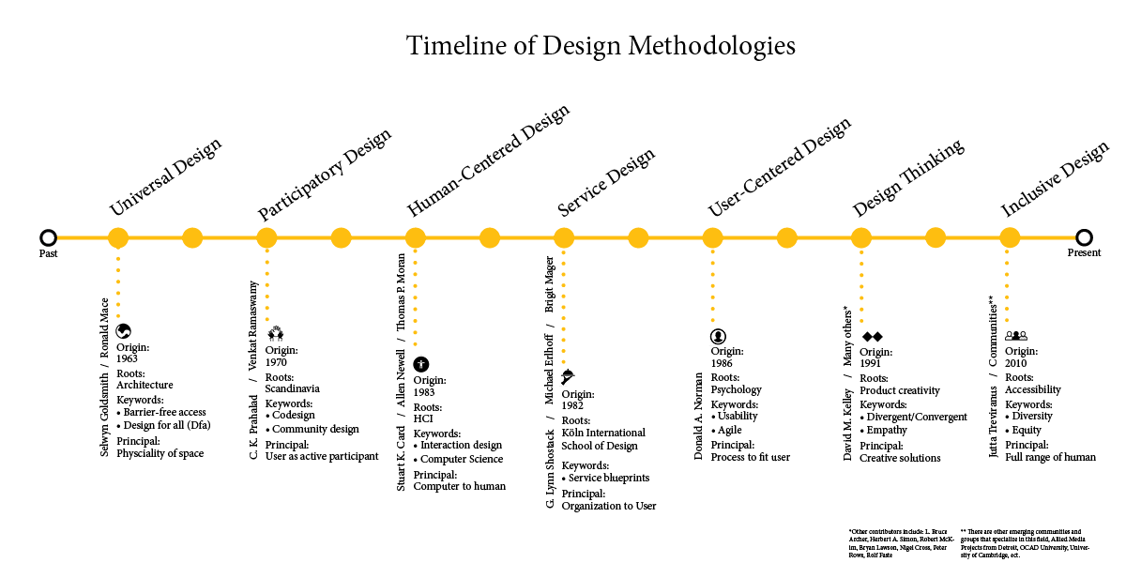

**Framework**

**Principles of Fair Design**

**Principles:**

**1. Value-Driven Goals – Define the value to be delivered through the product or service.**

**2. Representative Teams with Identities – Formalize a team with self-identifying members of the community in which the product will be designed for**

**3. Iterative CoDesign – Invite users from the community for codesign session in the design process**

**Iteration Process:**

**1. Interact – Immerse all members of the team, even the decision-makers into the real world to uncover the authenticities**

**2. Involve – Invite users of all levels and accessibility needs to track points of view in order to find common trajectory of value delivery system**

**3. Invest – Invest in prototypes by prioritizing outcomes that will satisfy all potential users**

**Methodology**

**The Fair Design Kit**

* **CoDesign Studios**
* CoDesign studio sessions, or Cooperative Design comes from Participatory Design movement from the 1970’s. The aim of CoDesign is to involve members from the public to the creative practice of design. This ensures that real users are not only consulted in order to gain data, but that they take active roles in voicing their concerns and their experiences to interact with the designers as much as possible. \
* CoDesign studios should be an active part of each iterative loop in the Fair Design method, with care taken to invite members of different racial, ethnic, class identities with varying accessibility needs. CoDesign studios should always be: Inclusive, Community-Driven, and Safe Spaces. In order to encourage innovations to foster, truly collaborative and safe spaces are mandatory to the creative process. CoDesign Studio Facilitator should be trained in standardized methods in order to facilitate and manage a room full of strangers to work together collaborative to come up with ideas. Keep in mind that since CoDesign studios invite members outside of the organization and institutions, there is always a danger of unpredictable attendees. The studio sessions should be ran by professionals who can properly mediate unexpected situations with proper de-escalation techniques for internal quarrels. Therefore, the safety of all members involved during the studio session should be emphasized. Some equipment needed would be an open space with chairs and walls where people can post sticky notes.

## 4.3 Fair Design Exercises

**Deconstructing the Boxed-In User**

**Duration:** 30-60 minutes.

**Materials needed:** Sticky Notes

**Description:** This exercise involves techniques of scenario application to redefine uses of a product that may have obvious or set use cases in mind. Give examples of well known products or services that exist today and ask the participants to create personas and think of scenarios where this product can be used for. Apply accessibility design techniques to decontextualize the product’s use case for a user with sensory impairments. Ask the participants to create personas again and think of scenarios for the second time, but with restrictions in visibility, auditory, or mental illness difficulties that could act as a barrier between the user and the product.

**Aim of Exercise:** To allow designers to realize that persona or proto-persona creations are often boxed-in to certain type of users, and introduce critical thinking techniques to encompass a greater sensibility towards the meaning of a “user”, and redefine the user under various contexts outside the boxed-in scenarios.

**Immersive Experience**

**Duration:** 2-3 weeks of planning, 2+ hours of activity

**Materials needed:** Voluntary organizations with access to community

**Description:** This exercise involves techniques applied at Pixar. A field trip or immersive experiences are considered a mandatory part for animators who about to enter into a 2-3 year animation project that tells the story of a target culture or community. Designers need to get out of the building and immerse themselves in the environments of their users to gain an intimate understanding. Unlike ethnographic research, which relies on the designer to observe and often times not engage with their participants, this immersive experience trip allows full engagement and interaction between designers and user groups, by inviting designers to spaces where their users are.

**Aim of Exercise:** To allow designers to realize to gain experience within the target community that their design is aiming for.

**Imitation of Lived-In Experience of Persona**

**Duration:** 5-10 minutes

**Materials needed:** Phones, devices, sticky notes

**Description:** This exercise involves techniques from theatre. It is to engage the participants to pretend to be a persona created from previous exercises. Participants will be paired up with one being the observer, the other being the user persona. The persons will have one or more identity trait that will define how they are able to interact with their device, whether it be an physical need (eg. Hard-of seeing) or mental need (eg. Stress, Time-restraint, ect.) The participants will be asked to engage with the device of choice as if they are the personas, and asked to do simple task (eg. Calling a friend). They must navigate through the system as their persona while their partner actively observe their actions and track their decision made within the product. Partners will be asked to reflect to each other about how they interacted with the system changed, given the role of the persona, and write down their learnings on sticky notes.

**Aim of Exercise:** To allow designers to conceptualize actual use of their product in the real-world.

**Future Steps**

The value of Fair Design is unhindered access to information by all. Fair Design works to dismantle homogeneity that exist to threaten creativity and positive innovations for the future. User experience should be a practice that is embraced by everyone, not only the designers. Design can be rooted in prejudice and ignorance, and in our future where there will be more technological innovations and information available than ever before, access to information must be a right redeemable by any human, despite their identity or community. Elitism in the design world kills creativity, and we must design with inclusivity and fairness in mind from the very start, rather than teaching the importance of marginalized experiences as an afterthought or going back to designs and fixing products to become accessible. Fair Design hope to provoke the question: In our advancements of technology, are we socially progressing as a society?

The goal of the design kit and the exercises in Fair Design is to set people on a different direction. Designers have more power than ever before to create positive impact in their line of work. The role of designers is not confined to usability, profit-driven research or interface design. It is the responsibility of the designer to provide access to information to the users who need and deserve it. Access to information is a right, and in this way designers become ethical bridge makers that allows the user to gain the information they need.

Poorly equipped designers who fall back on mainstream user experience methodologies to build services for the homogenous users will not able to thrive in our ever-shifting society, where values of users change over time. It will be more crucial than ever to implement ethics-based approaches to design moving forward. Future steps for Fair Design will include consultation with expert leaders in the field of design to make the methodology a reality, and to create an open community where as many marginal voices can be captured and amplified in the making of the Fair Design. A future goal of Fair Design would be to incorporate ethical impacts of design to be a main disciplinary component of user experience education.

​